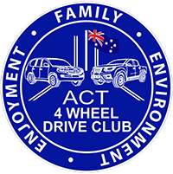
TRIP ADVERTISEMENT
Trip Details (to be completed by Trip Leader and forwarded to tripcoordinator@act4wdclub.org.au)
Trip Name
& Destination
Trip Date
Trip Leader Name
Contact Details (Mb and Email)
Trip Grading and Total time
(see Trip Grading in newsletter)
Departure Time
& Departure Point
Fuel Availability
Maps or Google Map reference
Max Number of vehicles
Camper Trailers/Caravans | Please put notes here about suitability or not for camper trailers and caravans if it’s an overnight trip and could turn muddy or snow or become a narrow track
Special Equipment needed  (note some gear can be shared) | Recovery Gear and Points are a must:  - AT tyres minimum, diffs locks will be handy  - UHF radio  - Morning tea and lunch  - ‘I will have 2 spare portables if you don’t have one.  - We will be on Channel 20 unless that’s busy.'
Comments: (ie: planned trip details) | Note:  - Meet at xxxx xxx  - Head along the aaa Rd and stop to air-down
Note: Trip leader to record the names of all participants for insurance and report purposes.

All participants are to make themselves familiar with the following Trip Docs on our website before joining a trip:
- Trip Risk Assessment
- Minimum Trip Equipment Standards
- ICE Trip Form for Glovebox
- Convoy Procedure Policy
- ARMA Code Of Conduct for 4WDs
www.act4wdclub.org.au 17.2.2026

