ACT4WDClub Clothing 24.9.26
Please email a completed order form to Clothing@act4wdclub.org.au $8 extra for your name on your shirt. 1 garment minimum order, $20 post, freepost for $300 or more.
(S/S – Short Sleeve L/S – Long Sleeve L/W - Light Weight M/W - Medium Weight)

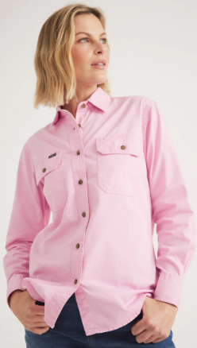
Stock on hand - reduced by 1/3 to clear them, 40% of the new price.

14 L/S Ladies shirts - Stock on hand (at old prices):
1 - 10 Blue (L/S ½ button, ACT4WD words on front) $45 $30
4 - 12 Pink (L/S ½ Button, ACT4WD words on front) $45 $30
1 - 12 Blue (L/S ½ Button, ACT4WD logo on front) $45 $30
4 - 14 Pink (L/S, ACT4WD words on front) $45 $30
1 - 16 Pink (L/S, ACT4WD words on front) $45 $30
2 - 18 Pink (L/S, ACT4WD words on front) $45 $30
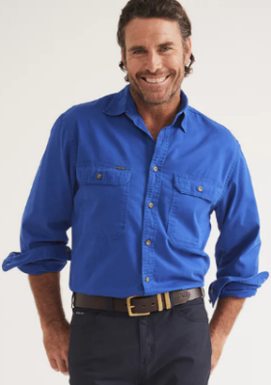
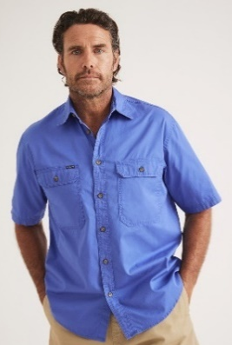
1 - 18 2nd Hand VGC - Pink Polo Shirts L/S, ACT4WD words $10

5 Men’s shirts - Stock on hand (at old prices):
1 - L Polo S/S M/W with ACT4wd logo $45 $30
1 - L L/S M/W with ACT4wd logo $45 $30
1 - L L/S M/W with ACT4WD words $45 $30
1 - 3XL S/S with ACT4wd words $45 $30
1 - 5XL S/S M/W Half Button with ACT4wd logo $45 $30

3 Jumpers - Stock on hand (at old prices):
1 Medium Jumper with ACT4wd logo + Words on the back - $36 $47.40
1 Medium Jumper with ACT4wd words on front - $32 $47.40
1 Large Jumpers with ACT4wd logo - $32 $47.40
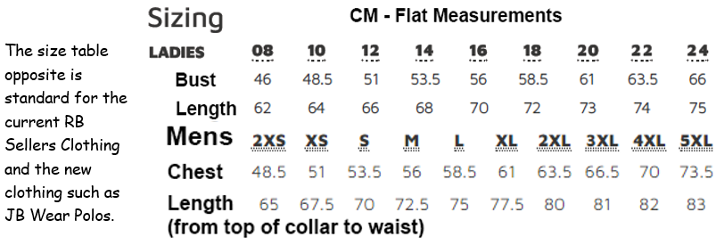
Caps and Beanies with ACT4wd logo - $10 – buy at the meeting
ACT4WD Club Clothing with Club logo - new supplier orders (+$8 for your name)
16.6.26 Email a completed order form to clothing@act4wdclub.org.au
Note: All orders incur a $20 postage cost if orders under $300 in total, not charged if more.
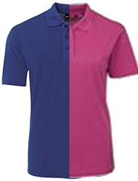  1 | 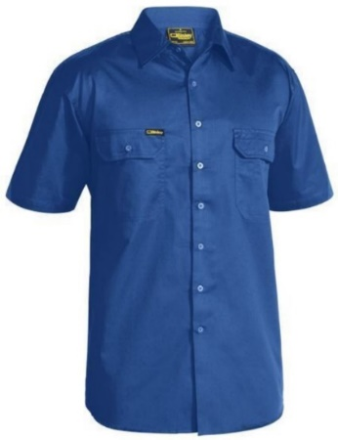  2 | 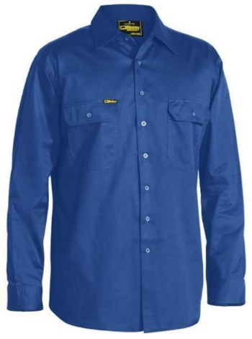  3 | 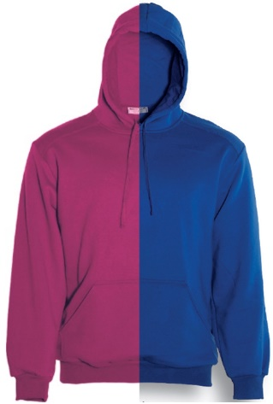  4
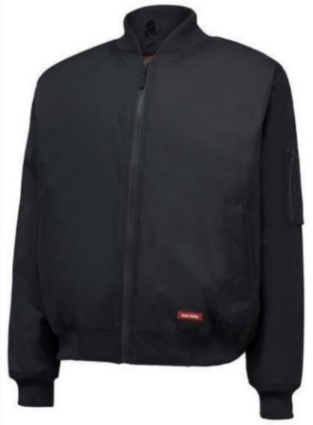  5 | 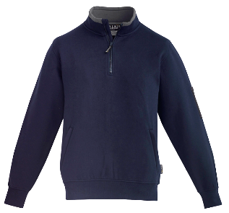  6 | 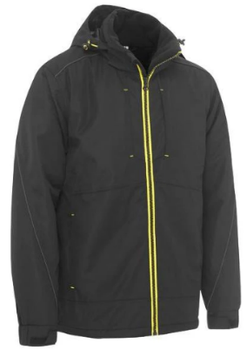  7 | 8
Member name:  Date: |  |  | $Total (inc $20 Delivery)
P  i  c | Clothing order – Ozzieworkwear  (Prices include logo) | Size | Colour | Qty | Name on Shirt? +$8 | $Total  (inc $20 Del)
1 | $28 JB's Men’s Pocket Polo Size S-5XL, Royal Blue |  | Royal Blue
1 | $25 JB's Ladies 210 Polo Size: 8 - 30 Hot Pink or Royal Blue |  | Hot Pink or Royal Blue
2 | $50 Bisley Cool Lightweight Drill S/Sleeve Shirt, Royal Blue, S-6XL |  | Royal Blue
3 | $55 Bisley Cool Lightweight Drill L/Sleeve Shirt, Royal Blue, S-6XL |  | Royal Blue
4 | $35 Bocini Unisex Adults Pull Over Hoodie Hot Pink & Royal Blue, XS-7XL |  | Hot Pink or Royal Blue
5 | $70 Hard Yakka Waterproof Bomber Jacket, Navy, S - 5XL |  | Navy
6 | $65 Syzmik Men's 1/4 Zip Brushed Fleece Navy/Charcoal, XXS-5XL |  | Navy/ Charcoal
7 | $120 Bisley Flex & Move Wet weather Jacket, Black, XS - 6XL |  | Black

